**DAT 205 Capstone**

**NBA Toronto Raptors Team Performance**

**Team Proposal Report – Final Plan**

|  |  |
| --- | --- |
| **By** | **Group 1**  Bhavika Patil  Cindy Guo  Dennis Hung  2021-03-18 |

Table of Contents

Section 1. Business Goal 3

Section 2. Analytics / Data Mining Goal 3

Understanding the Data 3

Analysis 5

Section 3. Implementation / Production 6

References 7

Figures

Figure 1 Example PlayerGameLogs data subset 3

Figure 2: Available features for data between 2005 to 2020 (NBA Media Ventures, LLC., 2021) 5

Figure 3 High level project schedule and milestones 6

Figure 4 Gantt Chart of the overall project plan 6

# Section 1. Business Goal

The Toronto Raptors are an NBA championship team with a $2.5 billion market capitalization that is in decline after being crowned 2019 NBA champions. They were able to add key players in their championship run that year and allowed them to edge out critical key wins in the playoffs.

The team’s General Manager (GM) and Owners are seeking recommendations on improving the team’s chances at another championship run but not at the cost of the team’s long term future. This would be in the form of marginal/minor improvements to the player roster to either maintain or improve on the number of wins during the regular season and more importantly during the playoffs.

The organization is not necessarily seeking to rebuild the core team players but to improve the team’s performance and thus maintain the public’s interest in the team. Another trip to the NBA finals while maintaining the number of regular season wins would be ideal.

Section 2. Analytics / Data Mining Goal

To fulfill the requirements outlined by management, we are looking to determine what features affect team wins/losses and predict how this can be improved/reduced through changes in the team’s roster.

## Understanding the Data

The actual statistics is gathered from the NBA.com website. NBA API (Patel, 2020), created by Swar Patel is used to gather the historical NBA player statistics from NBA.com. By applying various endpoints (the method to request information through the API) we were able to obtain various NBA data.

* PlayerGameLogs endpoint gathered the statistical data of each player in each game by season (figure 1). This consisted of 34 possible features from the year 1946 to the present day for approximately 1,367,432 records.

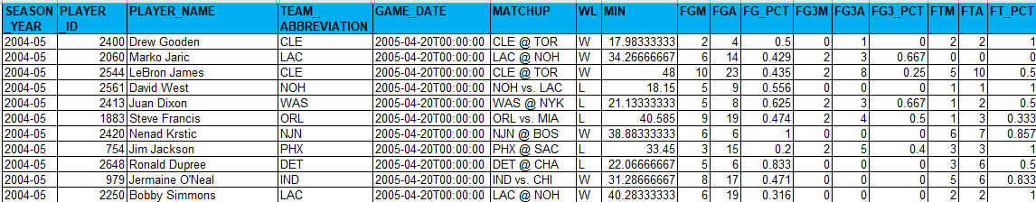

Figure 1 Example PlayerGameLogs data subset

The dependent/target feature is Win/Loss (WL) of a game as we are looking for players that will help win games. Knowing this then classification models such as Logistic Regression, Decision Trees, or Random Forests will be applied for our analysis.

|  |  |  |  |
| --- | --- | --- | --- |
| **Attributes** | **Data Type** | **Example value** | **Comments / Definitions** |
| **SEASON_YEAR** | STRING | 2015-16 | NBA season |
| **PLAYER_ID** | INT | 202710 | Player Unique ID |
| **PLAYER_NAME** | STRING | Jimmy Butler | Player name |
| **TEAM_ID** | BIG INT | 1610612741 | Team Unique ID |
| **TEAM_ABBREVIATION** | STRING | CHI | Team 3 character abbreviation |
| **TEAM_NAME** | STRING | Chicago Bulls | Team name |
| **GAME_ID** | STRING | 0011500103 | Leading zeros and this needs to be text |
| **GAME_DATE** | DATETIME | 2015-10-23T00:00:00 | Date/Time game is played |
| **MATCHUP** | STRING | CHI vs. DAL | Teams featured in the game |
| **WL** | STRING | W | The player who was on the team who won/lost |
| **MIN** | FLOAT | 24.25 | Minutes Played The number of minutes played by a player or team |
| **FGM** | INT | 2 | Field Goals Made The number of field goals that a player or team has made. This includes both 2 pointers and 3 pointers |
| **FGA** | INT | 7 | Field Goals Attempted The number of field goals that a player or team has attempted. This includes both 2 pointers and 3 pointers |
| **FG_PCT** | FLOAT | 0.286 | Field Goal Percentage The percentage of field goal attempts that a player makes Formula (FGM)/(FGA) |
| **FG3M** | INT | 0 | 3 Point Field Goals Made The number of 3 point field goals that a player or team has made |
| **FG3A** | INT | 0 | 3 Point Field Goals Attempted The number of 3 point field goals that a player or team has attempted |
| **FG3_PCT** | FLOAT | 0 | 3 Point Field Goal Percentage The percentage of 3 point field goal attempts that a player makes Formula (3PM)/(3PA) |
| **FTM** | INT | 0 | Free Throws Made The number of free throws that a player or team has made |
| **FTA** | INT | 0 | Free Throws Attempted The number of free throws that a player or team has attempted |
| **FT_PCT** | FLOAT | 0 | Free Throw Percentage The percentage of free throw attempts that a player or team has made Formula (FTM)/(FTA) |
| **OREB** | INT | 0 | Offensive Rebounds The number of rebounds a player or team has collected while they were on offense |
| **DREB** | INT | 3 | Defensive Rebounds The number of rebounds a player or team has collected while they were on defense |
| **REB** | INT | 3 | Rebounds A rebound occurs when a player recovers the ball after a missed shot. This statistic is the number of total rebounds a player or team has collected on either offense or defense |
| **AST** | INT | 6 | Assists The number of assists -- passes that lead directly to a made basket -- by a player |
| **TOV** | INT | 1 | Turnovers A turnover occurs when the player or team on offense loses the ball to the defense |
| **STL** | INT | 1 | Steals Number of times a defensive player or team takes the ball from a player on offense, causing a turnover |
| **BLK** | INT | 1 | Blocks A block occurs when an offensive player attempts a shot, and the defense player tips the ball, blocking their chance to score |
| **BLKA** | INT | 0 | Blocks Against The number of shots attempted by a player or team that are blocked by a defender |
| **PF** | INT | 3 | Personal Fouls The number of personal fouls a player or team committed |
| **PFD** | INT | 0 | Personal Fouls Drawn The number of personal fouls that are drawn by a player or team |
| **PTS** | INT | 4 | Points  The number of points scored |
| **PLUS_MINUS** | INT | 11 | Plus-Minus The point differential when a player or team is on the floor |
| **DD2** | INT | 0 | Double Doubles The number of double-doubles (double-digit number total in two of the five categories in a game) a player achieves |
| **TD3** | INT | 0 | Triple Doubles The number of triple-doubles (double-digit number total in three of the five categories in a game) a player achieves |

Figure : Available features for data between 2005 to 2020 (NBA Media Ventures, LLC., 2021)

## Analysis

The objectives of this analysis is

1. is to primarily determine what features are important to the Toronto Raptors team to produce more wins in the regular season and the playoffs
2. review team players’ performance-to-cost effectiveness

Not all the data will be relevant for this analysis. The focus is on the historical player data from 2005 to 2020 as this closely represent the players of the current era. Toronto Raptors 2019-20 season for team and players statistics will be the baseline to see what are the team’s weak / strong features.

To simplify the analysis the following assumptions were made:

* Changes are only applied to the Toronto Raptors and the statistics from other teams are not affected or changed
* Obtaining any players is up to the Raptors’ GM to determine if they will pursue the player via free agency, trading of players, etc
* This is a one-time report at this time

# Section 3. Implementation / Production

The overall implementation will be in 5 phases with a deliverable provided at the end of each phase (figures 3 and 4). Completion of the final report is targeted for Apr 15th along with a presentation to summarize the stakeholders on the recommendations outlined in the report.

The final results of the analysis will be provided in a detailed report and a presentation summarizing the results of this analysis to the Toronto Raptors organization. The expectation is to provide recommendations on the factors that either improve on team wins or reduce team losses. This information is for used by the General Manager group and/or scouting team to narrow down the search for role players based on the features important to improving the team roster.

|  |  |  |  |  |
| --- | --- | --- | --- | --- |
| **ID** | **Deliverable / Action Item** | **Milestone (Due Dates)** | **Start Date** | **End Date** |
| **S1** | **Team Case Proposals** | **2021-03-04** | **2021-02-25** | **2021-03-04** |
| **S2** | **Final Plan** | **2021-03-18** | **2021-03-04** | **2021-03-13** |
| **S3** | **Interim Presentation** | **2021-03-25** | **2021-03-13** | **2021-03-25** |
| **S4** | **Final Report** | **2021-04-08** | **2021-03-13** | **2021-04-03** |
| **S5** | **Final “Boardroom” Presentation** | **2021-04-15** | **2021-04-03** | **2021-04-15** |
|  | **Implementation** | **2021-04-15** | **2021-03-01** | **2021-04-12** |
|  |  |  |  |  |

Figure High level project schedule and milestones

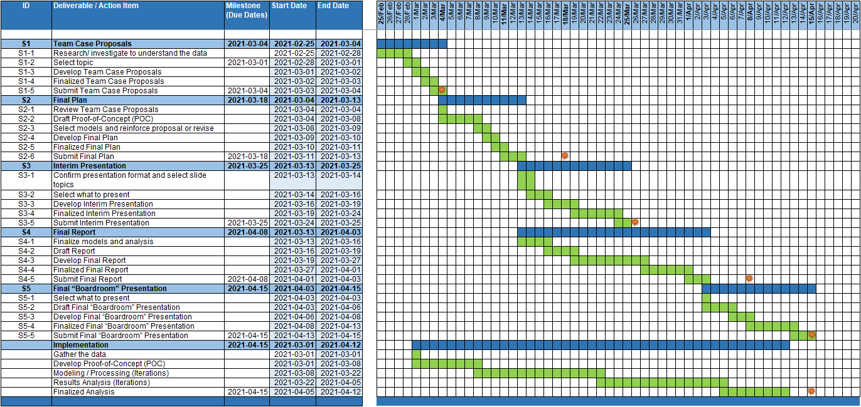

Figure Gantt Chart of the overall project plan

References

Bleacher Report, Inc. (2021). *Advanced NBA Stats for Dummies: How to Understand the New Hoops Math*. Retrieved from bleacherreport.com: https://bleacherreport.com/articles/1813902-advanced-nba-stats-for-dummies-how-to-understand-the-new-hoops-math

ESPN. (2020-2021). *NBA Player Salaries 2020-2021*. Retrieved from ESPN.com: http://www.espn.com/nba/salaries

HoopsHype. (2020-2021). *NBA Player Salaries*. Retrieved from hoopshype.com: https://hoopshype.com/salaries/players/

Jee, K. (2019, December 22). *How to Get NBA Data Using the nba_api Python Module (Beginner).* Retrieved from Playing Numbers: https://www.playingnumbers.com/2019/12/how-to-get-nba-data-using-the-nba_api-python-module-beginner/

NBA Media Ventures, LLC. (2021). *NBA Advanced Stats*. Retrieved from NBA.com: https://www.nba.com/stats/

NBA Media Ventures, LLC. (2021). *NBA Advanced Stats - Glossary*. Retrieved from nba.com: https://www.nba.com/stats/help/glossary/

Patel, S. (2020, August 19). *swar / nba_api.* Retrieved from GitHub: https://github.com/swar/nba_api/blob/master/docs/table_of_contents.md

SportRac. (2021). *Toronto Raptors 2020 Salary Cap*. Retrieved from spotrac.com: https://www.spotrac.com/nba/toronto-raptors/cap/

Sports Reference. (2020-2021). *2020-21 NBA Player Contracts*. Retrieved from Basketball Reference: https://www.basketball-reference.com/contracts/players.html

Sports Reference. (2020-2021). *Basketball Reference*. Retrieved from Basketball Reference: https://www.basketball-reference.com/